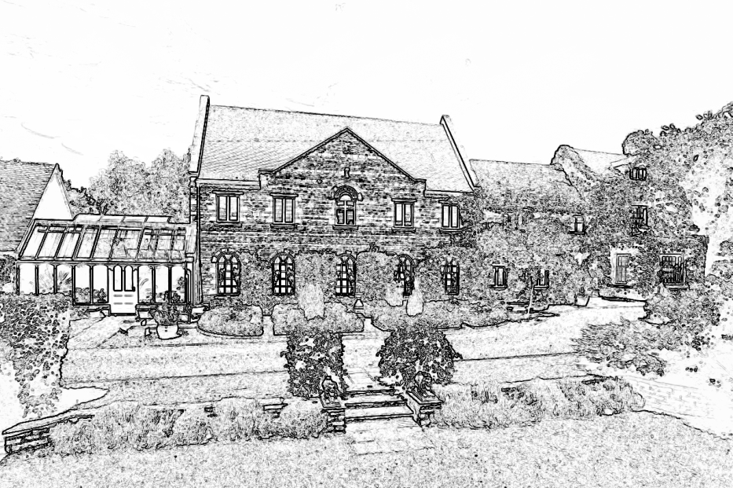

Wilds Lodge School

Guidance for Staff:

THE USE OF RESTRICTIVE INTERVENTIONS

This document was compiled by: Mr Robin Lee, Principal

In consultation with: The School Leadership Team
Safeguarding Team

September 2019

Review Date: September 2020

Doc. 2.14

INTRODUCTION

The document draws on guidance from the Education and Inspections Act 2006, DCSF Guidance on Pupil Behaviour and Discipline Policies April 2007, DfE Guidance on the Use of Force to Control or Restrain Pupils 7/11, Legislation on Keeping Children Safe in Education September 2016/2018, Safer Recruitment in Education 2007 and Guidance for Safe Working Practice for the Protection of Children and Staff in Education 2015 and, Use of reasonable force, DfE 2013, Equalities act 2010. It aims to clarify for staff, parents, pupils and the SLT the position over the use of force to control or restrain pupils. It should be read in conjunction with the school Behaviour Management Policy.

Section 550A of the Education Act (1996) entered the statute books on 1st September 1998. It remains the guiding legislation for practitioners managing difficult behaviour within schools. It recognises that the use of restrictive physical interventions may be necessary to prevent pupils committing crime; causing injury or damage; or causing disruption. It clarifies the powers of teachers and other staff who have lawful control of pupils, to use reasonable force to manage these behaviours. It has been designed to permit decisive and professional interventions by members of staff within schools. DfEE Circular 10/98 noted that such powers were already existent under common law, but had often been misunderstood.

The text written in italics in this paper are extracts taken from Circular 10/98

2. SCHOOL EXPECTATIONS

These guidelines have been kept as brief and as straightforward as possible. This has been done deliberately because the primary purpose of this document is to produce a policy that is clearly workable, easily understood and serves to protect the interests of both the staff and the students at Wilds Lodge. It is necessary to draw attention at this point to the very special approach provided by the school, which is fully described within other documents in the staff handbook. In particular the Behaviour Management Policy will need to be read and understood and used in conjunction with this policy document. It is sufficient to note that all professional staff will have to intervene with difficult and challenging students during the course of their daily work. The importance of skilful interventions as incidents arise, develop and are worked through cannot be highlighted enough. It is essential that the procedures described in this paper are not used instead of this ‘process’. The use of physical force that is unwarranted, excessive, or punitive is not acceptable. It is within our therapeutic context that this framework for intervention must be understood and implemented.

3. Section 550A

This section allows teachers, and other persons who are authorised by the Principal to have control or charge of pupils, to use such force as is reasonable in all these circumstances to prevent a pupil from doing, or continuing to do, any of the following:

- Committing a criminal offence (including behaving in a way that would be an offence if the pupil was not under the age of criminal responsibility);

- Injuring themselves or others;

- Causing damage to property (including the pupil’s personal property);

- Engaging in any behaviour prejudicial to maintaining good order and discipline at the school or among its pupils, whether that behaviour occurs in a classroom during a teaching session or elsewhere.

The provision applies when a teacher, or authorised person, is on the school premises, and when he or she has lawful control or charge of the pupils concerned elsewhere e.g. on a field trip or other authorised school activity.

Wilds Lodge is, as previously noted, a school both under its terms of registration with the DFE and the Children Act 1989. Its aim and purpose is to provide a 24-hour academic and social curriculum to address the social, emotional and behavioural difficulties of its students. The guidance provided in this document is as equally applicable to care and therapeutic staff carrying out their professional duties as to teaching staff in their teaching and extraneous duty roles.

4. Authorised Staff

The Act allows all teachers at the school to use reasonable force to control or restrain pupils. It also allows other people to do so, in the same way as teachers, provided they have been authorised by the Head teacher to have control or charge of pupils. Those might include classroom assistants; care workers, midday supervisors, specialist support assistants, education welfare officers, escorts, caretakers, or voluntary helpers including people accompanying pupils on visits; exchanges or holidays organised by the school.

Within Wilds Lodge School, because of the particular needs and difficulties presented by the students, the only staff authorised to use reasonable force under the terms of the Act are the teaching, learning support, care, pastoral and therapeutic staff. At Wilds Lodge it is our policy to ensure that staff are trained and have up to date Team Teach Certificate.

All professional staff at Wilds Lodge have been trained in TEAM TEACH strategies and techniques for positive intervention. The initial training and regular refresher sessions are contractual requirements. The school retains the right to insist that all the adults who are expected to intervene physically when necessary, can do so with the greatest degree of safety to themselves and the student.

5. Positive Behaviour Management

All staff should adopt a positive approach to improving behaviour in order to reward effort, develop positive relationships and to help build the student’s self-esteem. In order to do this, those working with the child should work in partnership with colleagues, both from within school and from outside agencies, who know the student well to:

- Find out why this student behaves as he or she does;

- Understand the factors that influence this student’s behaviour;

- Identify early warning signs that indicate foreseeable behaviours are developing.

- Use 95% talk down techniques and de-escalation

This approach will help to ensure that early and preventative intervention is the norm. It should reduce the incidence of extreme behaviours and make sure that the use of physical force is rare.

6. Types of Incident

There are a wide variety of situations in which reasonable force might be appropriate, or necessary, to control or restrain a pupil. They will fall into three broad categories:

- Harm to themselves our harm to others

b) Where there is a developing risk of injury or significant damage to property or criminal behaviour

c) Where a pupil is behaving in a way that is compromising good order and discipline and causing serious disruption

Examples of situations that fall within one of the first two categories are:

- A pupil attacks another member of staff or another pupil.

- Pupils are fighting;

- A pupil is engaged in, or is on the verge of committing, deliberate damage or vandalism to property;

- A pupil is causing, or is at risk of causing, injury or damage by accident, by rough play, or by misuse of dangerous materials or objects;

- A pupil absconds from a class or tries to leave the school. (This will only apply if a pupil could be a risk if not kept in the classroom or at school).

Examples of situations that fall into the third category are:

- A pupil persistently refuses to obey an order to leave the classroom;

- A pupil is behaving in a way that is seriously disrupting a lesson.

7. Risk Assessment and Planning for use of Restrictive Physical Interventions.

We have to acknowledge that some student behave in ways that make it necessary to consider the use of restrictive physical intervention as part of a behaviour management plan. All identified behaviours which might require a physical intervention should be formally risk assessed.

We have to be cautious about having a planned use for physical restraint as part of a management strategy for a student. Experience tells us that emotionally disturbed students can become reliant on the safety and abdication of responsibility that being held by safe and predictable adults can bring. However, we accept that physical intervention will be necessary on occasions, but also acknowledge that it can bring risks to both staff and students.

It can:

- Be used unnecessarily, when other less intrusive methods could be employed to achieve the same outcome;
- Cause injury;
- Cause pain, distress or psychological trauma;
- Become a routine, rather than exceptional method of management;
- Increase the risk of abuse;
- Undermine the dignity of the staff or student or otherwise humiliate or degrade those involved;
- Create distrust and undermine personal relationships.

However, the main risk of not intervening may be:

- A breach in the duty of care;
- People being hurt;
- Serious damage occurring to property;
- The possibility of litigation in respect of these matters.

8. Reasonable and proportionate Force

There is no definition of ‘reasonable force’: so it is not possible to set out comprehensively when it is reasonable to use force, or the degree of force that may be reasonably used. It will always depend on the circumstances of the case.

There are two relevant considerations:

- The use of force can be regarded as reasonable only if the circumstances of the particular incident warrant it. The use of any degree of force is unlawful if the particular circumstances do not warrant the use of physical force. Therefore physical force could not be justified to prevent a pupil from committing a trivial misdemeanour, or in a situation that clearly could be resolved without force.

- The degree of force employed must be in proportion to the circumstances of the incident and the seriousness of the behaviour or the consequences it is intended to prevent. Any force should always be the minimum needed to achieve the desired result.

9. Application of Force

Physical intervention can take several forms and might involve staff:

- Physically interposing between pupils;
- Holding;
- Leading a pupil by the hand or arm;
- Shepherding a pupil away by placing a hand in the centre of the back; or
- (In extreme circumstances) using more restrictive holds

The recognition given to the importance of touch when working with children with special needs is highlighted:

Young children and children with special educational needs may need staff to provide physical prompts or help. Touching may also be appropriate where a pupil is in distress and needs comforting. Teachers will use their professional judgement to determine when this kind of support is appropriate.

Staff training emphasises 95% is talk down techniques and distraction techniques that when staff are carrying out a physical intervention, only approved holds must be used and physical interventions must last for the shortest possible period of time.

Team Teach also states explicitly that staff should not act in such a way that might reasonably be expected to cause injury. The following are given as examples of approved team teach interventions which should be used.
- Guide
- Helpful hug
- Steering away
- One person single elbow
- One person double elbow
- Two person double elbow

10. Complaints

The possibility that a complaint might result in a disciplinary hearing, or a criminal prosecution, or in a civil action brought by a pupil or parent cannot be ruled out. In those circumstances it would be for the disciplinary panel or the court to decide whether the use and degree of force was reasonable in the circumstances. In that event, however, the panel, or court, would have regard to the provisions of section 550A. It would also be likely to take account the school’s policy on restraint, whether it had been followed and the need to prevent injury, damage, or disruption, in considering all the circumstances of the case.

11. Procedures Following a Physical Intervention

Incidents that require the use of restrictive physical interventions are likely to be distressing to all concerned and may result in injuries to the student or member of staff. Once the incident has calmed, it is important to ensure that the student and staff involved are given emotional support and basic first aid is available to deal with any simple injuries. The priority, of course, is for medical attention for any injury that needs more than basic attention. Any injury that needs professional medical assistance will need to be reported through the school Health and Safety requirements and recorded in the accident book.

Any physical restraint will need to be reported in detail:

(i) The circumstances (names of pupils involved, names of staff present, how the incident began and developed, how the pupil responded, the outcome of the incident), types of hold used); and its justification under Section 550A must be recorded as promptly as possible by the member(s) of staff in one of the school’s bound books kept for the purpose. This should be viewed as a safeguard for the member of staff in case of subsequent complaint.

Staff might find it helpful to seek advice from a senior colleague or a representative of their professional association when compiling a report.

(ii) The student must be examined for any injuries by a separate member of staff. A written note of the findings, even if nothing is noted, must be recorded in the bound book, alongside the details of the incident.

(iii) The student must be given the opportunity to put forward his account of the incident. He may require help writing it.

(iv) The student must be given the opportunity to talk through why a physical intervention was necessary.

(v) The parents, or those with parental responsibility, must be informed promptly.

vi) Social worker for LAC children must be informed promptly

12. Monitoring the use of Restrictive Physical Interventions

The School Leadership Team and the school’s TEAM TEACH instructors will review each incident of a physical intervention. This is essential to ensure that:

- The well-being of the students is promoted;

- The need for specialist help can be determined;

- The appropriateness of the student’s placement can be assessed;

- Only TEAM TEACH approved techniques are being employed;

- Future training needs for staff can be identified;

- A culture does not develop where physical responses are used at the expense of other interventions.

13. Responding to Complaints

The use of restrictive physical intervention can lead to allegations of inappropriate or excessive force being used. If this should occur, the matter will be dealt with in accordance to the school’s Safeguarding Policy (in the Staff Handbook).

