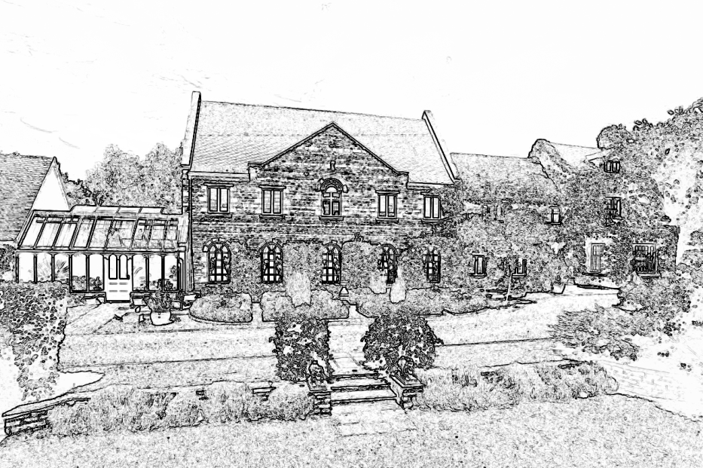

Wilds Lodge School

Guidance for Staff

HEALTH AND SAFETY AT WORK POLICY

This document was prepared by: Robin Lee, Principal

In consultation with: The School Leadership Team
All staff

September 2017

Review Date: September 2018

Doc. 3.12

1. Introduction

This document applies to all staff and students (both on and off-site), as well as to visitors to the Wilds Lodge Rock Lodges and Cross Roads sites.

Wilds Lodge recognises that it has a legal duty under the Health and Safety at Work Act (1974) to ensure as far as it is reasonably practical the health, safety and welfare of employees, and the health and safety of visitors, including students.

The school will set up and regularly review policies and procedures that will ensure a safe environment as far as is reasonably practical, and will consult and take into account staff and others’ proposals for improving health and safety standards in the school.

The whole policy will obviously rest on the willingness of all staff to meet essential standards of safety. This depends upon staff members being familiar with requirements being laid down in all areas. It also depends on their personal willingness to be alert and take responsibility for intervening in situations that may suggest risk or hazard for students and adults. No set of guidelines can cover every eventuality, which is why vigilance and initiative remain the most important factors.

2. Organisation and Responsibilities

- The employer is responsible for the health and safety of employees, students and visitors.

- The School Leadership Team will monitor the health, safety and welfare policies and procedures in the school.

- The Estates Manager is the school’s Health and Safety Officer (HSO). Robin Lee, Principal, and Mary Rennie, Head of School Support, Kristy Lamb Head of Therapy and Emma Mills Head of Education are the school’s ‘designated senior persons’ for all safeguarding matters.

- All members of staff form the Health and Safety Advisory Committee.

- Any union representatives may discuss health and safety issues with the HSO. The HSO will always take the views of staff and union representatives into account.

- All members of staff as employees have a duty to ensure as far as reasonably practical the health and safety of themselves, other employees, students and visitors.

- The School Council (students) will consider health and safety issues at its meetings. Estates Manager (HSO) and SLT will take the Council’s views into account.

- All students will be trained, as far as reasonably practical, in looking after their own health and safety, as well as that of others in the school.

3. Responsibilities

3.1 The School Leadership Team will:

- Ensure that an item is placed on the SLT agenda at least annually to receive reports on:

  - The implementation of the school’s health and safety policies and procedures and any changes since the last report;

  - Training undertaken by staff with specific health and safety and child protection responsibilities;

  - Fire drills;

  - The number of incidents or accidents;

  - Damage to the premises and grounds;

  - Any other health and safety issues in school;

  - Security issues;

  - The development of health and safety and child protection awareness in the student community.

    - Ensure that the receipt of all reports, regulations and guidance issued by the Government is minuted.

    - Ensure that all health and safety issues are minuted, and where relevant, followed up at subsequent meetings.

    - Ensure that appropriate risk assessments are made by the Estates Manager (the HSO), and all members of staff.

    - Ensure that the staff have an opportunity to discuss health and safety issues and to raise concerns.

    - Ensure that the students are taught to assess risks and to take appropriate action to avoid, or minimise, risks.

    - Ensure that the accident/incident books are inspected by the SLT regularly.

    - Ensure that the Principal accompanies the school’s designated HSO on an inspection of the school at least once per year, and makes a report of the inspection to the SLT.

    - Review any health and safety issues that have arisen in previous reports.

3.2 The Health and Safety Officer (HSO) will:

- Coordinate the whole-school programme after full consultation with the staff in appropriate meetings.

- Carry out inspections at least once a year and ensure that the necessary action is taken to remedy any deficiencies that have been identified.

- Set up and administer the system for reporting, recording and investigation accidents and take all reasonable steps to prevent a recurrence.

- Provide safety information and appropriate training to staff and students.

- Ensure that new employees are briefed about safety arrangements and are given a copy of the school’s health and safety policy (this document).

- Oversee the Fire Officer to ensure that effective arrangements are in force to facilitate ready evacuation of the buildings in case of fire or other emergency and that fire-fighting equipment is available and maintained, and that appropriate fire safety signs are in place.

- Oversee the Appointed Person (see First Aid Policy) to ensure the effectiveness and efficiency of the school’s medical and first aid provision.

- Ensure that an effective system for co-ordinating and managing outside activities is implemented.

- Oversee the Senior Teaching and Care Teams to ensure that appropriate systems and arrangements are in place to enable pupils with disabilities to have access to the curriculum and premises as far as is reasonably practical.

- Oversee and maintain the development plan to meet the requirements of the Disability Discrimination Act (DDA).

- Arrange for contractors and visitors to be informed of any hazards on the school premises of which they may be unaware.

- Ensure temporary employees are given sufficient information, training and supervision to enable them to be safe and without risk to their health.

- Co-operate with any appropriate Local Authority Health and Safety services.

- Ensure that health surveillance for staff is provided when necessary.

4. Information and Recording Systems

All reportable incidents will be recorded and reported according to the Reporting of Injuries, Diseases and Dangerous Occurrences Regulations (RIDDOR).

All ‘non-reportable’ accidents and incidents must be reported to the HSO, who will record them in the school’s Accident and Incident Logbook (BehaviourWatch).

5. Qualifications and Training

All employees must have a Disclosure and Barring Service (DBS) check and must receive on-site training in the relevant skills and techniques used by the school to ensure health and safety and child protection.

The HSO will ensure that all staff are trained in risk assessment.

6. Staff Duties

Educational staff will be allocated duties to safeguard health and safety before and after school, and at lunchtimes. Staff will be expected to perform the duties set out in the Staff Duties Procedures.

7. Risk Assessments

The school maintains a risk assessment database of generic risk assessments on:

- Accommodation
- Facilities
- Materials
- People

The risk assessments are recorded in a format provided by the school.

All pupils are risk assessed on admission to the school.

All risk assessments are reviewed annually and/or when an accident occurs.

All staff will be trained to risk assessments on the above, and will be expected to assess identified risks, and to manage them as far as is reasonably practicable.

Staff must inform the HSO of any risks they cannot manage.

8. Off-site Activities

Doc 4.4 Outdoor and Residential Visits within the staff handbook describes the procedures for all school trips.

9. Pregnancy

The school recognises that it is important to risk assess staff who are pregnant or new mothers. The HSO will assess the risks and take appropriate control measures in each case.

10. School Security

All visitors must be signed in and out, and must be aware of their health and safety responsibilities when on-site.

Nobody is allowed beyond the Reception area without the permission of the Principal or member of the SLT.

Any trespassers should be reported immediately to the Principal.

11. Occupational Health Services and Work Related Stress

The school will work with medical practitioners and/or local health services as appropriate.

It is recognised that working with students with social, emotional and behavioural difficulties can be stressful at times. All staff have a duty to inform the Principal if they are experiencing unreasonable or prolonged periods of stress. Similarly, they have a responsibility to advise the Principal if they are feeling ill.

12. Student Health, Medical and Child Protection Issues

All staff have a duty to inform the Principal if they believe that any student has a health or safety problem.

The Principal will ensure that appropriate action is taken, having consulted relevant persons as necessary.

13. Aggression Towards Staff

Staff are expected to inform the Principal if they are concerned about their safety.

Any incident of aggression towards staff must be properly recorded and the Principal must be informed.

At no time should staff be alone on site when students are present. For example, care staff going off-duty at the end of the evening should not leave the sleep-in member of staff before the night supervisor has arrived.

14. Slips and Trips

All staff should be on the look out for hazards likely to cause slips and trips. Staff have a duty to guard against these, or eliminate or avoid them if they can, or to draw them to the attention of the HSO.

15. On Site Vehicle Movements

All vehicles on site must keep to the vehicular entrance and exit and parking spaces, and must not encroach on the areas designated for pedestrian/play use.

Vehicles are restricted to 5 mph on the school site.

16. Maintenance

The school will follow a maintenance schedule set out by the School Leadership Team, after appropriate consultation.

All electrical equipment, plant and machinery will be tested and maintained as appropriate under the various regulations.

17. Manual Handling

All manual handling will be done in accordance with current regulations.

18. Fire Safety

The HSO will comply with the fire safety regulations and advice of the fire safety consultant, and will ensure that the fire fighting equipment is maintained, and that a log of fire drills is maintained.

Fire notices must be clearly visible in each room, and all staff and students must know the fire drill.

19. Display Screens

The provisions of the Display Screen Regulations will be applied to the staff as required by law.

As far as is practicable, the Regulations will also be used as guidance for the use of display screens by students.

20. Alcohol, Drugs and Controlled Substances

Illegal drugs or controlled substances must not be brought onto the school site at any time. Alcohol must not be brought onto the school site when students are resident. Separate documents within the staff handbook describe our approach to these matters.

21. Smoking

The school is a totally non-smoking area. Again, a school document within the staff handbook discusses our attitude towards smoking.

22. Medicines

The school conforms to all current regulations and will take into account current guidance on the issue of administering medicines.

The administration and recording of any medicine is the responsibility of the school nurse. All legal drugs are kept securely.

23. First Aid

All school at the staff will receive first aid training and the HSO, in consultation with the Heads of Care and the school nurse, will ensure that there are sufficient staff who are suitably qualified.

Document 4.6 in the Staff Handbook describes our First Aid procedures and practices.

24. Crises and Emergencies

The Principal is responsible in the event of a crisis or emergency for:

- Co-ordinating a response;
- Dealing with outside organisations and the media,
- Informing parents/carers and the placing authorities;
- The welfare of the pupils both on and off-site.

In the absence of the Principal, those members of the SLT present will assume responsibility.

All individual members of staff might be required to support the senior members of staff as necessary.

25. Reporting and Recording

The working of the Reporting and Recording Policy is reviewed annually.

