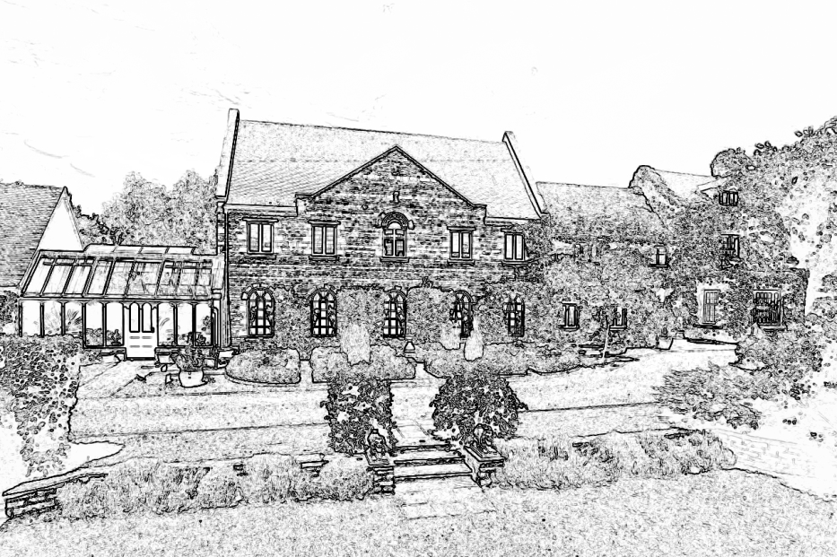

Wilds Lodge School

Guidance for Staff:

ANTI-BULLYING POLICY

This policy was compiled by: Robin Lee, Principal

In consultation with: The School Leadership Team

Safeguarding Team

January 2016

Review Date: January 2017

Doc. 5.4

Introduction

In this document, we are not concerned with those deeper personal, social, emotional or psychological issues that underlie and often precipitate bullying behaviour. What we are intent upon is a clear explanation of a set of attitudes and a related framework for intervention that will allow us to manage the problem of bullying behaviour in an efficient and effective manner. These guidelines are intended to help staff to develop a shared understanding of the problems involved in identifying, containing, reporting and intervening when we face bullying behaviour by our students. We need a team approach and a common sense of purpose. We must have a generally understood framework for action and procedures that are clear and workable.

This is an extremely important area. We work with students who exhibit social, emotional and behavioural disorders. They have often been hurt themselves. They often seek to retaliate against people and things. Containing these complex and persistent aggressions within the peer group is one of our primary professional tasks. Any failure to do so will release sub-cultural peer group reactions that may have serious consequences for a number of our students. We need to be aware of these peer group dynamics. We have to monitor the peer group very carefully for signs of intimidation and bullying. We must then take considered and decisive action.

Our Obligations

In developing a whole school policy towards bullying, we start with the knowledge that this behaviour, in all its forms, will occur from time to time in every school. It is an on-going feature of working with young people and a particular feature of our working with students with social, emotional and behavioural difficulties. It will always occur. This is the reality of our working situation and it is the point from which this discussion starts. The frequency and intensity of this problem will depend largely upon the ethos of the school, the intervention strategies we employ and our capacity to contain and manage the interpersonal behaviour of our students.

This implies a vigilant and consistent approach by all staff. We face an additional responsibility in the fact that most of our students are boarders. They are exposed to each other for far longer periods of time than in a day school. They do not go home to families at the end of the day. We carry, therefore, a very heavy duty of care for every student placed with us. Many are particularly vulnerable given the nature of their previous experiences. Our policy on bullying is one important aspect of our professional obligation to create a caring and protective environment for our students.
What is Bullying?

There are many definitions of bullying. At Wilds Lodge, we see it as inappropriate behaviour from an individual student or group of students towards another student that is deliberate, may be repeated over time, and is hard for the individual to defend against. It is essentially an abuse of power by a stronger student(s) against a weaker one. The advantage in strength may be either physical or verbal; it might be real or imagined; and can be expressed individually or collectively with others.

Examples of bullying in our context would include:

- Hitting and punching
- Kicking
- Spitting
- Spoiling someone else’s belongings
- Calling names
- Excluding
- Giving nasty looks
- Making racist or homophobic remarks
- Making comments about another student’s family
- Picking on a weakness
- Spreading rumours
- Preventing somebody from joining a game
- Not talking to someone or getting other people not to talk to another student
- Putting pressure on another student – for example, to run errands and do jobs, to give up possessions, to bring things from home

Emotional and Physical Symptoms Linked to Bullying

It is often hard to spot young people who are experiencing bullying. By its nature, it is an insidious activity that usually goes on out of sight of staff. The victim is often reluctant to come forward because they feel that ‘telling’ might only make matters worse for themselves and make the situation more intolerable. The following symptoms might be an indication that a student is being bullied:

Emotional
Lost confidence
Loss of self-esteem
Irritability
Aggression
Anxiety
Panic attacks
Depression
Suicidal thoughts

Physical
Sleeplessness
Nausea
Shaking
Heart racing
Laziness
Skin complaints
Stomach aches
Migraines and headaches

Who Bullies?

An in-depth discussion of why some young people become bullies is beyond the scope of this paper. Attention is drawn to the following websites:

www.bullying.co.uk
www.dfe.gov.uk/bullying
www.childline.org.uk
www.kidscape.org.uk
www.ncb.org.uk

It is clear from the literature that a significant number of our students experience home circumstances which foster the development of bullying attitudes – for example:-

- Poor parental role models;
- Aggressive male figures;
- Poor relationships with mother;
- Inconsistent punishment by parents;
- Physically and verbally aggressive adults.

“Bullies are associated with general anti-social rule breaking behaviour in school and in the community.”

“They are often aggressive towards parents, teachers, and siblings.”

“Contrary to popular belief, bullying victims don’t always differ much from other children.”

(Quotes from Tattum and Herbert, 1990)

Who are the victims?

Anybody can be bullied. There are, however, certain risk factors that will make the experience of bullying more likely. They include:

- Lacking close friends in school;
- Being shy;
- Coming from an over protective family environment;
- Having a different ethnicity, religion, or sexuality to the majority;
- Being different in some obvious respect from the majority;
- Having particular educational, social or medical needs;
- Being a ‘proactive victim’ – a young person who behaves inappropriately with others, barging in on games or being a nuisance.

None of these characteristics can excuse allowing a student to be bullied.

It is safe to assume that we are always going to have to manage a proportion of young people in our school who are potential (and actual) bullies and victims.

Our School Policy and Practice

The following guidelines provide a framework for containing and changing attitudes towards bullying. These have been compiled after much discussion among senior staff. They are aimed at creating an ethos that will not tolerate the oppression of one person by another. These guidelines aim to establish a whole-school policy and contain both long and short-term strategies that involve the school organisation and curriculum.

- All students, parents and staff must recognise that any form of bullying is completely unacceptable in our school. This message will be made explicit when a student and his family/carers first come for interview; it will be stated very clearly in the student handbook; and will be reiterated regularly in school assemblies and house meetings.

- No member of staff or student must ever ignore a young person being bullied or in distress as a result of being bullied. No tales of bullying must ever be discounted. They must be recorded and thoroughly investigated. In a boarding school there is always extra potential for surreptitious aggression. Seeing and doing nothing is professionally indefensible. It implies support for the aggressor and is just about the worst response an adult can offer. It offers no help to the victim and is an act of collusion with the bully.

- Every case of bullying must be followed up immediately.
(One study found 25% of teachers interviewed felt it was sometimes helpful to ignore bullying problems. This is not a view we subscribe to under any circumstances.)

1. The member of professional staff dealing with the incident must make an initial judgement as to its severity. More serious cases must be referred to a member of the School Leadership Team.

2. Any adult witnessing the incident must make a written report for the occurrence stating:

  - When?

  - Where?

  - What happened?

  - Who was involved?

  - How they dealt with it.

  - Action to be taken.

- The victim must be given the opportunity to record events in writing or to have his views recorded by an adult.

4. The alleged aggressor must also be asked to write his version of events, or have them written for him.

These four steps are essential. They allow senior staff to monitor the bullying/victim behaviours of individual students and to check its frequency throughout the school. It also provides information for the therapeutic staff to use in their work with the children.

5. Victims need to be given support. They will need re-assurance that the matter will be dealt with discretely and sensitively and that they will suffer no further occurrences of repercussions from disclosure. They are entitled to positive action: stopping the bullying immediately without implying that they are the cause of what has been done to them. As members of staff, we must ensure that this happens.

- Adults dealing with an incident must not be physically or verbally aggressive towards the aggressor. We must never bully the bully. It gives credibility, if we react in this way, to the very behaviour we seek to eliminate. We do, however, act very firmly and purposefully in our interventions with students who are producing anti-social hostile behaviour towards others.

7. The member of staff must make the unacceptable nature of the behaviour and its consequences clear to the bullying student. The range of sanctions available for minor incidents is outlined in the school behaviour policy. Something must be done, even if it is only discussing the incident with the individual and his care staff at the end of the school day. The student must see that any form of bullying is taken seriously.

Senior staff will deal with more severe incidents, parents, the Local Education Authority, and social worker (if applicable), will be informed in writing by the school Principal.

8. Suspension will be considered when there are repeated incidences of bullying. The Principal will make this decision, but it will only be used under very special circumstances. (See 3.2 Guidelines on Exclusion.)

9. The school will not hesitate to exclude students whom they believe jeopardise the safety of other children or continually threaten their right to safety. Again, this will be used very infrequently and only after very careful consideration and full consultation with parents and placing agencies.

Positive steps to prevent bullying:

Always be aware of the school’s physical environment. It is difficult to specify where bullying is likely to occur in buildings and grounds such as ours, but by visiting ‘quiet’ locations frequently and by knowing where all the students you are responsible for are playing/occupied (and with whom), difficulties are less likely to occur.

All staff must be vigilant for the early signs of distress in students such as:

- Isolation.
- A desire to remain with adults all the time.
- Erratic attendance.

Although these behaviours may be symptomatic of other problems, they may indicate that bullying is taking place. Likewise everybody must be observant for any other indications that a student is being targeted, such as:
- Personal equipment being ‘lent’ or going missing.
- Money received from home going quickly.
- Clothes being damaged.
- Bruising/injuries.

Students must not ‘buy off’ the bully with sweets or other ‘presents’ and they must never give in to demands for money. They are strongly recommended to talk to a member of staff, a student they trust or any name in their student handbook. (See Child Protection procedures (5.3) and the Student Handbook.)

- Students are not encouraged to hit back. We are a ‘talking’ school and never advocate aggression as a means of solving problems. It may well also be contrary to the young person’s nature. We seek to resolve conflict creatively and constructively.

- Non-violent behaviour must be recognised and celebrated. The means of rewarding it are detailed in the school’s Behaviour policy (3.3).

- The victims of bullies need their self-esteem raised through activities designed to improve their social skills. They need support from all the involved adults, both at school and at home, to counter feelings of inferiority and guilt. Suggestions for suitable activities and strategies are the responsibility of the psychological staff and will be reflected in individual care plans and the teachers’ planning documents.

- Any sexist, homophobic, and racist comments or language must be challenged. Once again, a failure to act implies concurrence. We have a very determined inclusion policy and the ethos we are trying to maintain is well documented.

- Bullying as a subject will be addressed in the following ways:

Educational: Assemblies
Class discussions
As a cross-curricular theme – especially in RE, English, citizenship, PHSE and art.

Care: House meetings
Individual care plans

Therapy: Group counselling
Individual counselling – particularly with regard to exploring the reasons for a pupil’s bullying/ victim behaviour

Ancillary/domestic/maintenance staff must be encouraged to report any incidents of bullying that they see. This coincides with their role in the school’s policy on behaviour. It is discussed regularly in their meetings with supervisory staff.

Monitoring

The monitoring of bullying should have regard to information about incidents of bullying and how they were resolved, both immediately and over the longer term. Monitoring procedures can be used for two purposes:

- To enable schools to follow up and record progress.

Individual incidents which, on the surface may seem to be an isolated occurrence, may be part of a much larger pattern of bullying behaviour. Monitoring can be helpful in identifying such patterns.

- To establish whether or not our anti-bullying practices are really being effective.

Records of incidents can show whether bullying is becoming less frequent or changing in nature. The results can provide insights into ways in which practice needs changing or adapting.

The behavioural monitoring records, which are maintained by the pastoral staff, contain reports of all incidents of bullying that occur during the school day. This is monitored on a regular basis by the Principal.

Conclusion

In conclusion the following points are worth re-iterating:

1. Bullying does not stop of its own accord. It must be stopped by all staff acting with a common purpose, through a commonly understood set of procedures. There is no perfect system for eradicating this problem. It is ever-present and needs to be dealt with firmly and constructively as part of the therapeutic ethos of the school.

2. Younger children who are bullied tend to become older children who seek to bully others. We need to break this pattern. We need healthy traditions that can only emerge from students feeling safe within our environment. How young people treat others depends very much on how they themselves are treated. We must at all times protect them from the bully.

3. Bullied children in boarding schools suffer doubly because they cannot leave the threatening context behind them at the end of the day. We need, therefore, to follow our system for identifying this behaviour very carefully and to ensure that we record and communicate what has been happening to other members of the team. This gives total (not part) protection and security for the student across the residential school experience.

4. A successful anti-bullying policy has the spin-off effects of a reduction in general anti-social behaviour in the school. This enhances the personal and social environment of the school. It gives the personal safety and protection to each student which is his right and which we must be constantly vigilant to maintain.

