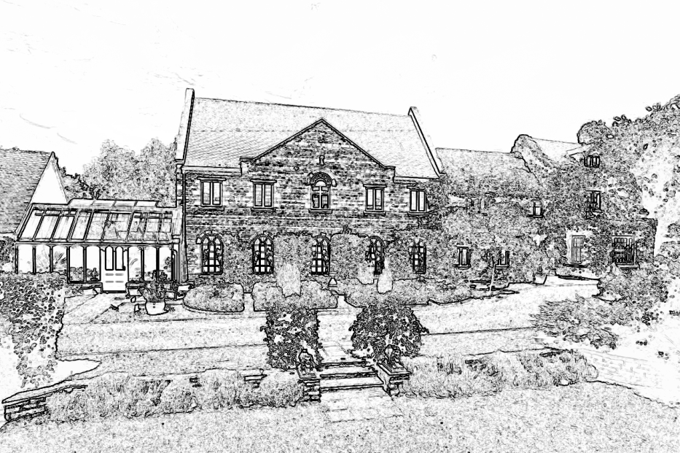

Wilds Lodge School

TEACHING STANDARDS AND CLASSROOM BEHAVIOUR

This document has been compiled by: Robin Lee, Principal
Emma Mills, Head of Education

In consultation with: The School Leadership Team

March 2016

Review Date: March 2017

Doc. 6.2

Good Teaching

Wilds Lodge has an unusually well qualified and experienced teaching staff. A number of our teachers have many years of successful experience in teaching SEBD students pupils and some have advanced qualifications in special education. Several have worked together over many years. This gives us great stability and a sense of team spirit. These are very positive features. The teaching team has changed considerably since the last Ofsted inspection. The ideas within this paper are shared perspectives on good practice and they are designed to further enhance our competence and the efficiency of our educational provision.

In the light of HMI guidance, it is important that there is no misunderstanding of those elements which constitute good teaching. In this document those fundamental ideas and practices, which are inseparable from the concept of good teaching, are emphasised. Our students cannot receive the quality of education to which they are entitled unless we all follow these basic principles.

- Planning

- Every member of the teaching staff must prepare schemes of projected work for all the subjects that they teach. The subject co-ordinators will monitor these long-term and medium-term planning documents.

- Thorough lesson preparation is absolutely essential. Clear learning aims and objectives must be present. The material must be differentiated to meet the needs of the individual pupil. The role of the teaching assistants must be considered. Any of the five outcomes of Every Child Matters that are addressed must be highlighted. Our lesson structure is guided by the Revised Key Stage 2 and 3 strategies. With SEBD students, interesting and well prepared material is absolutely vital if they are to engage actively with the learning process. Advance careful preparation is the key to success. Lesson plans will be monitored by the senior teaching staff (STT). It is important that planning is available.

- Subject development plans must be completed as advised by the STT, and certainly not less than annually.

- Teaching and Learning

- High standards of work and behaviour must be set and expected at all times.

- The lesson objectives should be communicated to the students at the beginning of the lesson.

- Teachers should seek to establish a balance between individual and group work. Well-organised and well-developed group teaching often gives a sense of cohesion and purpose to classroom activities. Equally, students need to take some personal responsibility for organising certain aspects of their work. Self directed knowledge is useful but it needs to be balanced against careful adult guidance and participation in group work and activities.

- Assessment, Recording and Reporting

- Proper assessment of learning that has been achieved is essential for future learning and progress. These assessments should be available to the STT and will support discussion and professional development.

- Students’ work should be marked promptly by teaching staff and in accordance with the school’s marking policy.

- Reporting to parents is similarly an important summary of progress. The attention of teachers is drawn to the advice given for educational reports in the school document describing our annual review practice.

- Behaviour Management

This is one of the most critical aspects of our discussion about teaching. None of the above characteristics of good teaching can come into practice unless a teacher is able to structure, control and maintain a well-ordered classroom environment. This is particularly important when we are dealing with SEBD students. Many have developed attitudes to class-work that are negative, anxious and hostile. Many have considerable problems of social interaction; they can exhibit abrasive behaviour that makes social co-operation in the classroom extremely difficult to achieve. It is not necessary to reiterate here the considerable range of emotional and social difficulties that characterise our students, but we are aware that many of our students are extremely difficult to manage, motivate and teach. We are also mindful of the fact that we are dealing with students at the extreme of the SEBD spectrum - students placed out of their home county by their LEAs.

However, in spite of these acknowledgements of the real difficulties the teaching staff have to face, the following principles are essential if we are to maintain satisfactory teaching standards throughout the school.

- Each teacher must take personal responsibility for establishing a peaceful and well-ordered classroom atmosphere i.e. an ethos for purposeful activity. The classroom must be seen as a place where students expect to work - classroom work is not optional.

- Each teacher must take personal responsibility for establishing a tradition of sensible behaviour. The idea of treating others with respect and care is a vital aspect of classroom ‘learning’. In this notion education takes on a wider meaning i.e. social learning and the way in which we treat others.

- Teachers set standards in the classroom. This applies to work and for behaviour.

- Teachers are aware of the 6 principals of nurture, creating a safe environment for pupils to learn about having a consistent approach to behaviour management.

What Are Reasonable Standards To Expect?

We need to have a very clear and consistent idea of what is acceptable in the classroom. There can be no shared professional standards in the school unless all the teaching staff follow the following rules:

- It is not acceptable for students to turn up late for lessons, or to be ‘missing’ for spurious reasons. (We have procedures for handling and reporting absentees from lessons.) Staff must make their own standards very clear to students in this respect.

- It is not acceptable for students to leave a classroom. Nothing is more calculated to ruin the effectiveness and continuity of lessons than an acceptance that students can walk out of a classroom. Teachers should allow this notion to become part of their working ethos. Students will quickly fasten on to any weakness in a member of staff’s attitude. Excuses should not be accepted.

- The students will exploit any weakness of resolve on the above principle. Some will seek to create conflict so that they can leave the classroom. Staff must not allow students to make these decisions. Immediate help can be sought, if necessary, from the pastoral staff or senior colleagues. The teacher is the adult. The teacher makes the rules and sets the standards in the classroom. If you do not clearly and firmly accept this responsibility the students will do so for you. Their standards will prevail. A settled working climate cannot be established in a classroom where children are allowed to come and go as they please. We must have a whole school policy on this because the teacher who does not maintain this principle with firmness and consistency is creating considerable problems for professional colleagues. A bad tradition in this respect will disturb the continuity of the education programme throughout the school.

- Every teacher will want to set very clear standards regarding interpersonal behaviour. We do not tolerate things like:

- Swearing and ‘calling’ other students;
- Unnecessary wandering about;
- Teasing and winding up other students;
- Fighting, hitting, or physically engaging with others;
- Disturbing other students’ work;
- Disturbing the working atmosphere of the class;
- Shouting out and being unduly noisy;
- Coming to class dressed in casual clothes;
- Damaging own work or that or other students.

- It follows that absences from class associated with things like copying, errands or taking messages must not be allowed. These casual excursions have a really de-stabilising effect on work expectations and upon the rest of the school. A teacher who has prepared a lesson properly in advance should not need to send students elsewhere for materials. This can also cause considerable problems for other staff. All teaching staff need to be absolutely consistent in ensuring that any practices of this sort do not occur.

These are basic standards that apply to every classroom in every school. They are the principles on which sound educational and interpersonal standards are built. Good teaching depends on the ability of teachers to convey these standards to their students. The fact that we deal with SEBD students does not exempt us from these first order requirements. We need to be extra sensitive about inculcating good working traditions in our students.

The manner in which these objectives are achieved depends on the individual skills and capabilities of teaching staff and also upon the various aspects of our school policies. i.e. to rewards, success, discipline, encouragement, control, therapeutic intervention and so on. Whole school policies exist to provide professional back up in these collateral areas of support. However, the final responsibility lies with each teacher in each individual lesson. Your skill, professionalism and standards are the over-riding factor in determining the effectiveness of our teaching programme.

The Quality of Lessons.

The most important themes recorded by Ofsted in judging the quality of lessons that were cited in the original document, still remain a useful baseline against which we can set our own performance.

The best lessons had the following characteristics:

- They were well planned and had a clear focus;
- There were clear explanations so that the students understood the tasks
they were set;
- The teachers had high expectations of the students’ performance and
behaviour;
- The teachers exhibited enthusiasm for their subjects;
- The teaching was linked to prior learning;
- Lessons had effective starts and endings;
- A lot of positive feedback was used;
- Students had some degree of choice;
- Students engaged with the work and with each other co-operatively;
- Students used a variety of recording methods;
- Students showed interest, enthusiasm and positive attitudes;
- Students took a pride in the presentation of their work;
- Students were confident enough to pose questions and volunteer their
own views.

A decade later, the inspectorate would add:

- The use of ICT to enhance learning;
- The deployment of teaching assistants to support learning and ensure equality of access for all students;
- The involvement of students in assessing their own learning;
- The implementation of the KS3 Strategy in structuring a lesson;
- A recognition of the 5 outcomes of Every Child Matters.

Poor Lessons were characterised by:

- Poorly planned work by the teacher;
- Instructions being insufficiently clear;
- Little sense of achievement or understanding;
- Insufficient demand and expectations from the teacher;
- Inconsistent and poor management of student’s behaviour;
- A lack of co-operation by the students;
- Unfinished work;
- Students being inclined to be over-dependent on adult help;
- Poor student attitudes, concentration and behaviour;
- The introduction of concepts too advanced for the students to
understand;
- A quote -”such lessons started late, lacked pace and behaviour
deteriorated.”

