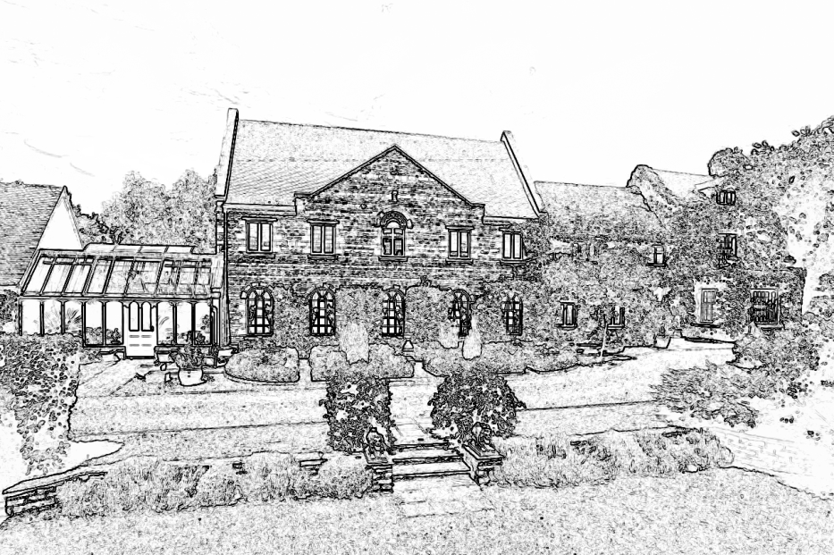

Wilds Lodge School

Purpose
Wilds Lodge School Behaviour Policy Senior Leadership Team (SLT) Statement of Principles September 2017.
This document contains the Senior Leadership Team (SLT) statement of principles for behaviour. It is used to guide the Principal in drawing up the school behaviour policy.
The actual production and implementation of the behaviour policy is the responsibility of the Principal, with the support of the Senior Leadership Team (SLT).
The Senior Leadership Team (SLT) Values, Beliefs and Principles
The Senior Leadership Team (SLT) wish the school to promote these values, beliefs and principles in the behaviour policy:
All members of the school community (pupils, staff, parents/carers and SLT) should show respect for one another;
All members of the school community should be listened and responded to;
All members of the school community are entitled to work and learn in a safe and secure environment;
All members of the school community should be considerate towards the learning needs of each individual and supportive of the school as a learning community.
The behaviour policy should reflect the shared aspirations of all members of the school community;
Good behaviour should be actively promoted and encouraged. All school staff should model positive behaviour;
All members of the school community should understand and accept the behaviour policy;
There should be active development of pupils’ social, emotional and behavioural skills;
Restorative justice should be used, where appropriate, to resolve disputes and incidents;
Good behaviour should be rewarded consistently and sanctions applied consistently;
Pupils whose behaviour and attendance may deteriorate due to circumstances outside of their or the schools’ direct control (such as bereavement, abuse, divorce, separation of parents) should be identified and supported;
Where appropriate, the Senior Leadership Team (SLT) and Principal should work positively with outside agencies;
Bullying is unacceptable.
Equality
The Senior Leadership Team (SLT) expects the behaviour policy and any related policy or procedure to be produced in accordance with equality legislation and the duty to eliminate discrimination.
Contents of the Behaviour Policy
The Senior Leadership Team (SLT) offer guidance that the behaviour policy should contain the school rules;
- Details of how good behaviour is promoted, including acceptable rewards;
- Details of how unacceptable behaviour is discouraged, including restorative justice and sanctions;
- Details of how serious and persistent unacceptable behaviour will be managed.
- Details of the exclusion policy; mention of and reference to the anti-bullying policy.
The Senior Leadership Team (SLT) is satisfied that the Principal has given full consideration to DfE guidance on the contents of the school behaviour policy.

